semantic elements

WHAT ARE SEMANTIC ELEMENTS?

Semantics is the study of the meanings of words and phrases in language.

Semantic elements are elements with a meaning.

A semantic element clearly describes its meaning to both the browser and the developer.

Examples of **non-semantic** elements: <div> and <span> - Tells nothing about its content.

Examples of **semantic** elements: <form>, <table>, and <img> - Clearly defines its content.

WEB PAGE STRUCTURE

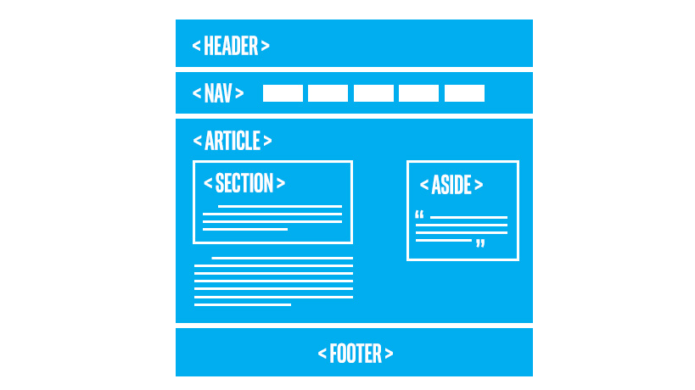

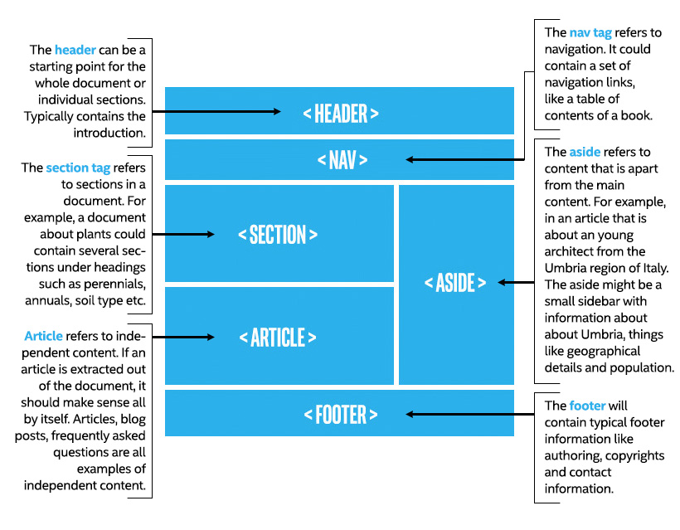

The use of these semantic elements improve the **automated processing of documents** It also improves the **accessibility** of webpages.